**Guide to Backup Monitoring for Saturn Account**

Version: 1.1

|  |  |
| --- | --- |
| Abstract: | This document will show us the process of Backup Monitoring for Saturn Account. |
| Protective Mark: | DXC |
| Document Number: | 1.0 |
| Document Author: | Swapna Kumari |
| Document Reviewer: | Dipayan Dakshi |
| Document Approver: | Dipayan Dakshi |

Amendment Record

|  |  |  |  |
| --- | --- | --- | --- |
| **Version Control Log** | | | |
| **No** | **Date** | **By** | **Nature of change** |
| 0.1 | 18 January 2021 | Swapna Kumari | Created document. |
| 0.2 | 18 June 2021 | Swapna Kumari | Updated document |
| 0.3 | 16 August | Swapna Kumari | Updated in new DXC format |
|  |  |  |  |
|  |  |  |  |
|  |  |  |  |

**Guide to Monitor Backup Monitoring for Saturn Account**

Kindly refer to Access creation document for Generating your first level password, Team membership and Extra access



**Steps to Login**

1. We need to connect to Full VPN DXC Pulse

2. We need to connect to SGW-Pulse

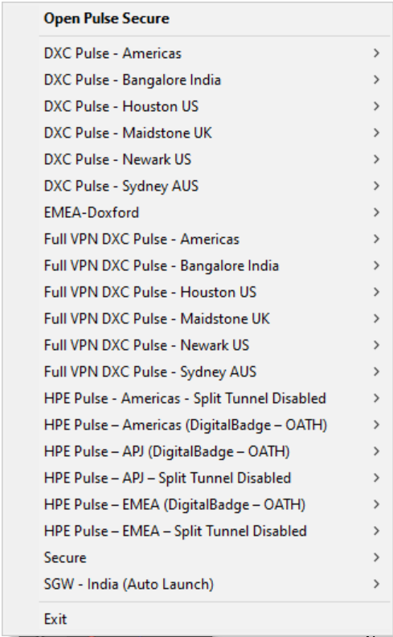

3. Add your username and onelogin password + security code as mentioned in the below screenshot

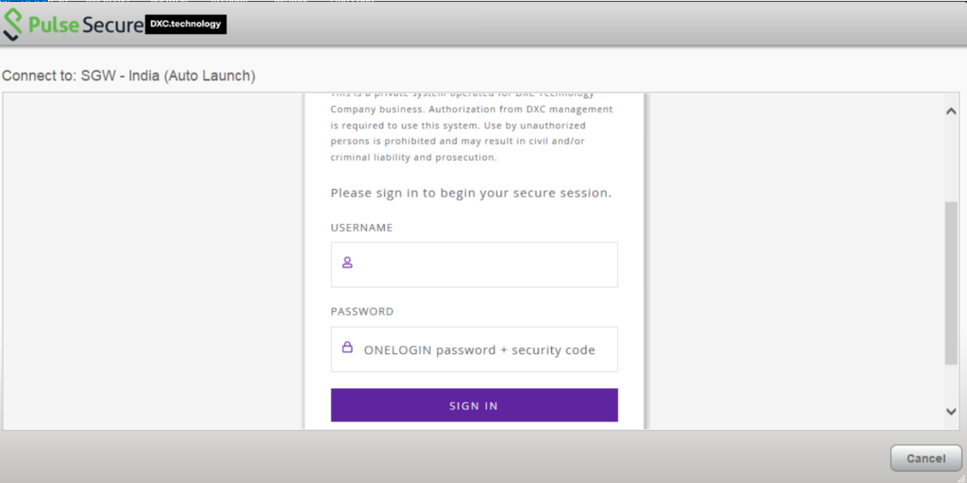

4. Now open this link in Internet Explorer: <https://remconn.svcs.entsvcs.net/_media/compartments:dedicated:dxcsaturnhop01.resrc.entsvcs.com.rdp>

5. A pop-up will appear. Click on Open



6. Click on Connect.

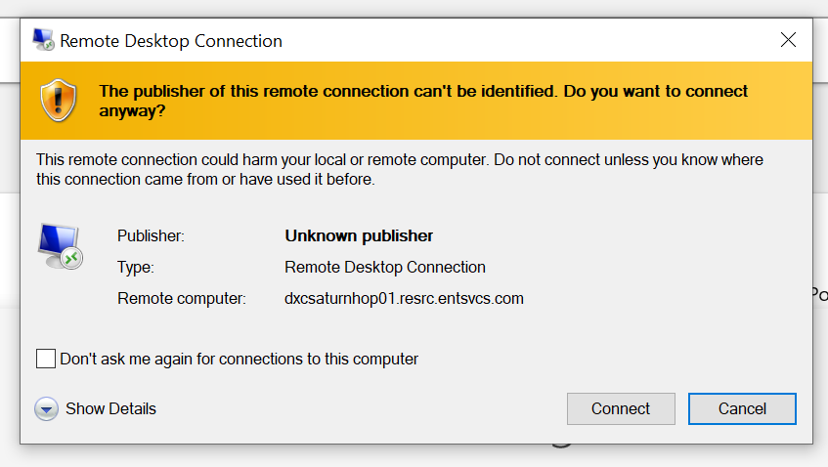

7. Login with your username and first level password.

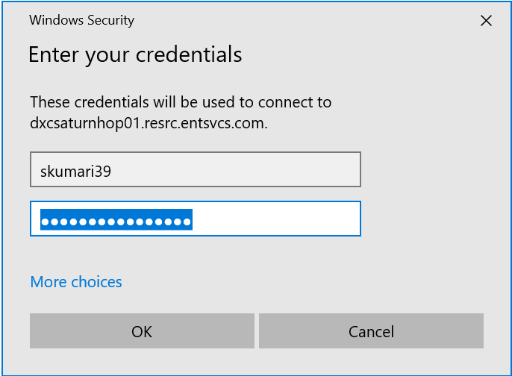

8. After login to the server. Go to Start menu and click on **NetBackup 8.2 Administration Console**

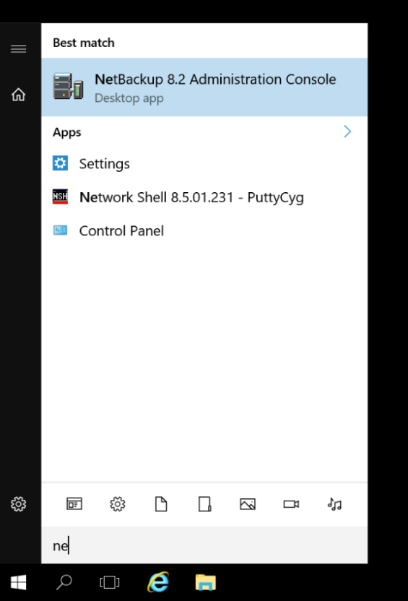

9. To login NetBackup console we need to use SaturnMgmt Username and Password as mentioned in below screenshot.

Host IP: 10.15.58.33

Host IP:10.15.58.133

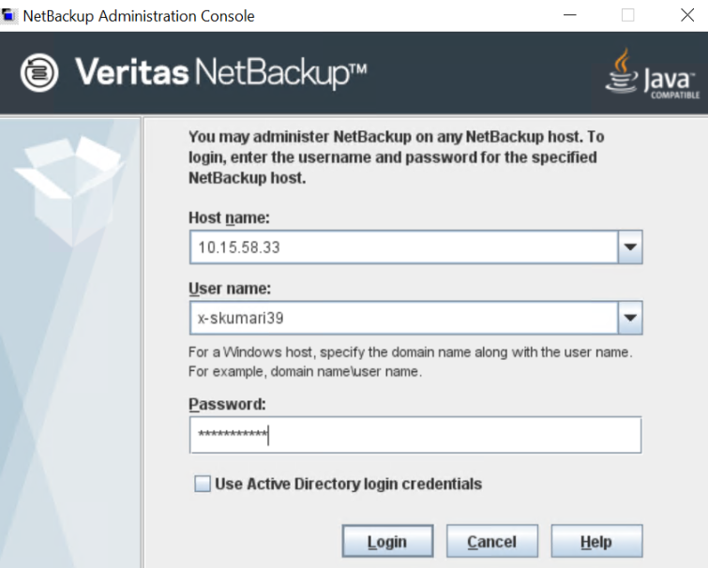

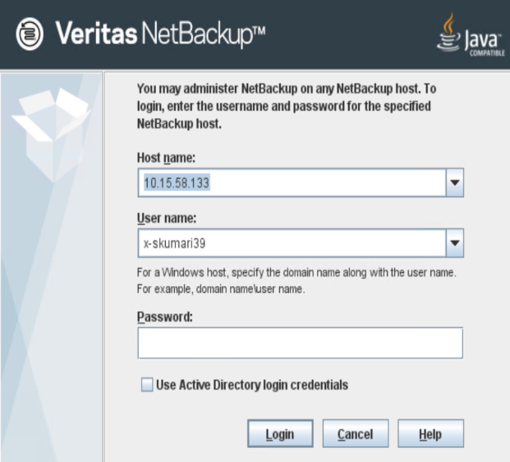

We need to login to both these servers via netbackup and the process remains the same for both.

**How to monitor Backups**

Click on Activity monitor tab.

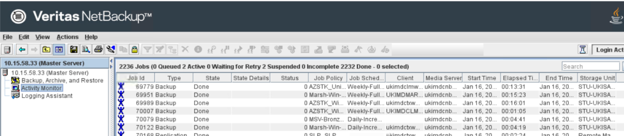

We need to check for the status code and if its 0 then the backup has been completed successfully.

For other backup codes mentioned below we need to restart the jobs whether the status is completed with exception, incomplete or failed. Ensure to restart just the child job not the parent job.

|  |  |
| --- | --- |
| Failure | Action |
| Status Code – 13 | Restart |
| Status Code – 1 | Restart |
| Status Code – 196 | Restart |
| Status Code – 50 | Restart |
| Status Code – 24 | Restart |

Apart from these status codes if we receive any other then directly raise a P4 ticket for the Backup Team. If the backup fails everyday, then we need to create a P3 ticket.

* Also, we need to restart the backup failures that are requested by the Backup Team.
* Every failure will equate to one ticket.
* In an event of multiple backup failures with same error code. Inform on-call and they will advise on the further actions.
* Every incident should be raise under Backup Bin BackupSupport – LONM” .

## Example for parent and child jobs

### You must restart that job whose type is “backup” which is highlighted below containing the mentioned status code as above for which we need to restart.

### No need to restart REPLICATION, IMAGE, CLEANUP, IMPORT, snapshot, export.

### If we receive such Types in Failed State, Completed with exception, Incomplete then we need to consolidate it and send the report at the end of each shift to the backup Team.

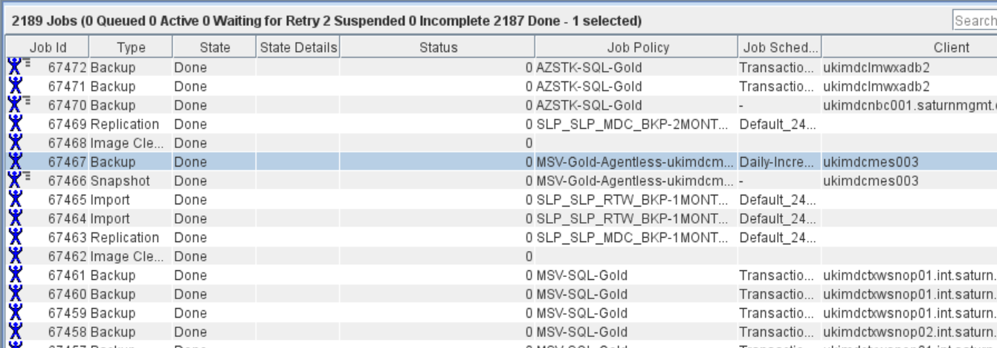

### You have to restart only child job not parent job in below scenario highlighted jobs are child jobs and jobs whose Job SCHEDULE IS “-“ARE parent jobs.

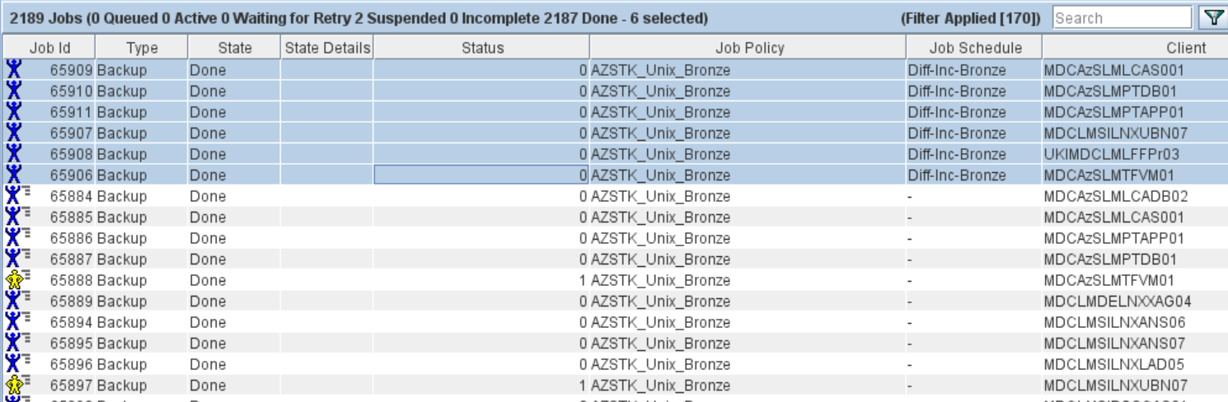

### For agentless backup i.e vm level backups and sql backup highlighted below NO need to restart any job for such backup jobs just raise incidents (Severity as P4)

Agentless backup i.e., vm level backups

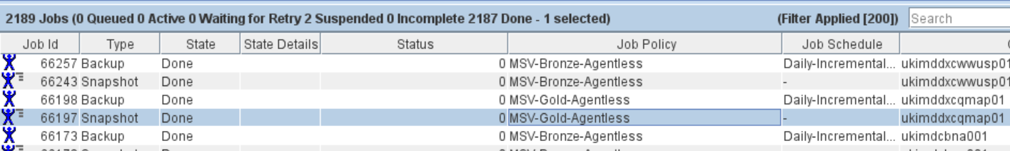

Sql backups

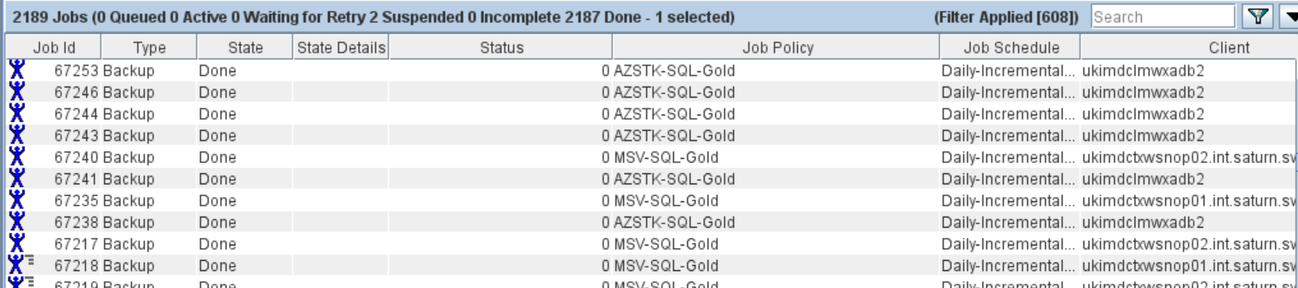

### In case any wrong backup triggered please terminate/cancel that backup jobs and inform to backup guys.

### In case of multiple failures with same error code =>50 PLEASE raise sev 2 ticket to backup bin and inform us.

For State as Active we need to check if the Kilobytes are increasing for the backup or not. If they are not increasing even after 30 mins of time, then that means the backup is in hung state.

In such scenario we need to inform to the backup team.

DPA Report Process:

We will receive a DPA report every day at around 1:00 PM IST.

For every unresolved backup in the DPA report we need to check the recent status of the client. If there are failure, then we will not re-run the backup and directly create a ticket if there is no existing ticket for the same client in open state.

Please find the screenshot of DPA report for reference:

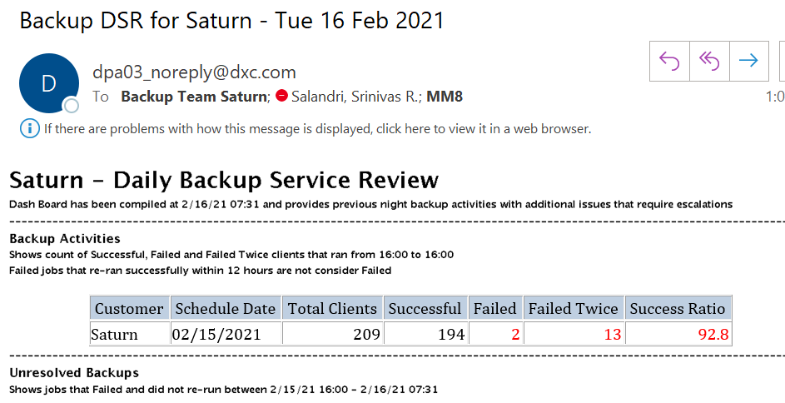

**Ticket Creation Process**

Refer to the below screenshot for ticket creation process.

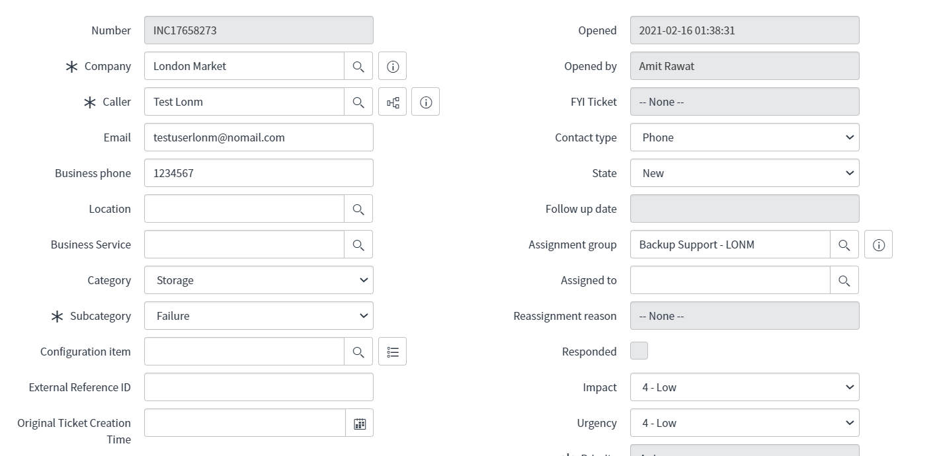

Escalation and notification

RMS Team

|  |  |  |  |
| --- | --- | --- | --- |
| 1st Level | RMS Team | [aoi@dxc.com](mailto:aoi@dxc.com) | 24x7 |
| 2nd Level | Dipayan Dakshi | [ddakshi@dxc.com](mailto:ddakshi@dxc.com) | 8106618782 |
| 3rd Level | Hemant Bidichandani | [hbidichandan@dxc.com](mailto:hbidichandan@dxc.com) | 9560079226 |

Backup Team

|  |  |  |  |
| --- | --- | --- | --- |
| 1st Level | Backup Team | [backupteamsaturn@dxc.com](mailto:backupteamsaturn@dxc.com) | +91 9892492986, +91 8978439183 |
| 2nd Level | [Team Lead - Manu Sharma](mailto:msharma219@dxc.com) | [msharma219@dxc.com](mailto:msharma219@dxc.com) | +91.729.199.8219 |
| 3rd Level | [Jain, Nitesh](mailto:njain38@dxc.com) | [njain38@dxc.com](mailto:njain38@dxc.com) | +91 7838090618 |